Media contact:

Jméno: Aneta Oščádalová

Agentura: AMI Communications
Telefon: +420 735 545 280

E-mail: aneta.oscadalova@amic.cz

MARS INTRODUCES NEW SUPPLY CHAIN DIRECTOR FOR CENTRAL EUROPE

Prague, March 13, 2019 — Mars, one of world's leading food and petfood manufacturers, introduced a new member to its Central European leadership team. Sophie Gaspard is joining the Central Europe leadership team as Supply Chain Director. The introduction of Sophie Gaspard is contributing to the company’s already high percentage of women leaders: as 7 out of 10 members of Mars’ Central Europe leadership team are currently women.

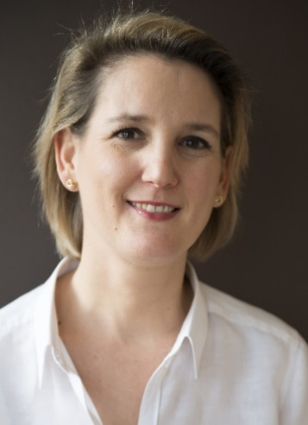
Sophie Gaspard is an experienced professional in the field, with over 18 years in supply chain management. She has joined Mars in 2008 and has since held a number of roles both in local markets and at a regional level. In her previous role, as Supply Chain Excellence Director for Europe and Russia in Confectionery division of Mars, she was a member of the Regional Supply Leadership Team. Prior to this, Sophie has played roles leading European projects and has been part of the French market management team.

In her new role Sophie is responsible for overseeing and managing the company’s supply chain in Mars Central Europe, including Czech Republic and Slovakia. Sophie is French which brings a nice extra diversity to the broader Central European team, now reaching over 15 nationalities.

„Mars has a unique corporate culture, which enables all of us to constantly learn and develop. I am very pleased and excited to gain new professional experience in the Central European markets, in a team full of talented Associates. I will be focusing on partnering with our customers and our logistics providers to drive excellence in Supply Chain.” said Sophie Gaspard.

# #
Mars in Central Europe
Mars entered the Czech market in 1992. The Czech market is since 2016 organized under the roof of Mars Multisales Central Europe, connecting Hungarian, Czech, Slovak and Romanian markets. With 540 employees (called Associates), the organization operates in three categories today: confectionery (chocolate, gum & confections), food (rice and sauces) and pet nutrition. In addition to this, Mars runs in region two of its biggest factories in segments, including a factory in Csongrád-Bokros Hungary, producing dry pet food and treats, and also a non-chocolate confections production facility including Mars’ confectionery development center in Poříčí nad Sázavou in the Czech Republic.
Mars, Incorporated
Mars is a family-owned business with more than a century of history making diverse products and offering services for people and the pets people love. With almost $35 billion in sales, the company is a global business that produces some of the world’s best-loved brands: M&M’s®, SNICKERS®, TWIX®, MILKY WAY®, DOVE®, PEDIGREE®, ROYAL CANIN®, WHISKAS®, EXTRA®, ORBIT®, 5™, SKITTLES®, UNCLE BEN’S®, MARS DRINKS and COCOAVIA®. Mars also provides veterinary health services that include BANFIELD® Pet Hospitals. Headquartered in McLean, VA, Mars operates in more than 80 countries. The Mars Five Principles – Quality, Responsibility, Mutuality, Efficiency and Freedom – inspire its more than 100,000 Associates to create value for all its partners and deliver growth they are proud of every day.
You can find more information about the Mars company at www.mars.com. Follow us on social media: Facebook, Twitter, LinkedIn, Instagram and YouTube

