Orbit created New Year’s yoga challenge:
Join #OrbitChallenge!

Prague, January 7, 2019 – Almost all of us have made a New Year’s resolution in some point in our lifes. But how long did the strong will last? Orbit and Airwaves chewing gums decided to motivate anybody wanting to make their lifestyle healthier this year and created a true challenge for them! Starting beggining of January you can watch ten videos with yoga classes taught by a professional yoga instructor and healthy lifestyle enthusiast Karin Dimitrovová at www.orbitklub.cz/orbitchallenge. So leave your excuses behind and join 21 days long challenge, brand new video will be released every other day. Sugar-free chewing gums can be a great partner not just for exercising but also when you have a sweet tooth. Now you can buy them in useful multipack package that contains 5 packages for the price of 4. As a part of the challenge there is a chance to win VIP ticket to Orbit Yoga Fest prepared in cooperation with Puma, taught by the ambassador Karin herself. Follow Orbit Klub on Instagram and join us!

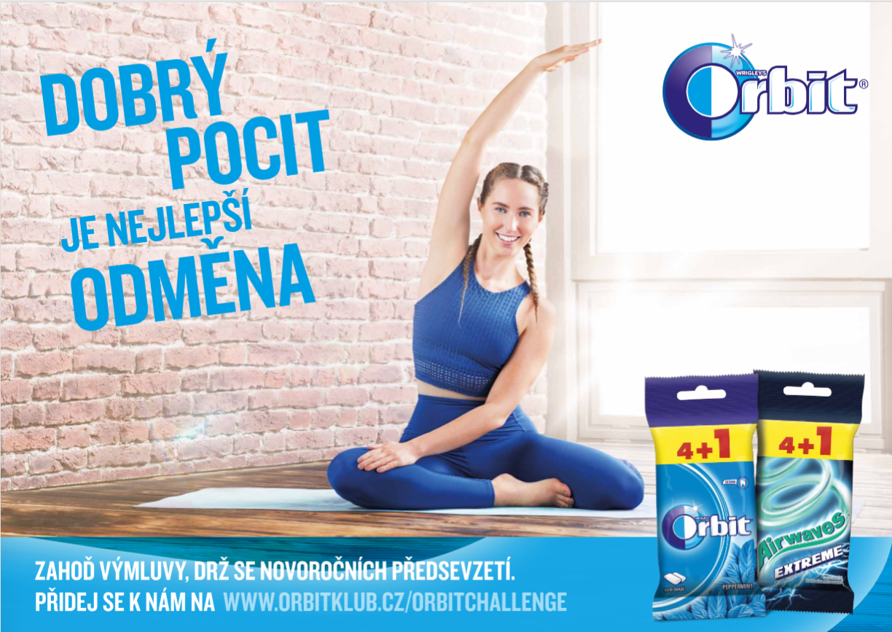
Chew for a better you
New Year asks for a new beginning. So let’s leave everything old and already passed behind. Let’s also leave behind all excuses and get started! Being active and fit helps us feel great and more confident. Orbit created a challenge not just for experienced yoga enthusiasts. It’s a New Year so why not start doing something new? At www.orbitklub.cz/orbitchallenge starting in January yoga instructor Karin will step by step guide you through basic yoga positions, teach you how to be calm, balanced and how to relax, so that you can feel better about yourself. Orbit and Airwaves chewing gums can be a big help as well. They will not just make your mouth feel fresh but they can also serve as a great guilt-free reward. No matter what flavor you choose – from peppermint to any of the fruity ones - all Orbit and Airwaves chewing gums are sugar-free which you will surely appreciate especially while pursuing healthier lifestyle in the beginning of the New Year.

Orbit Yoga Fest
Are you dead serious about your New Year’s resolution? Then follow Orbit Klub on Instagram, join #OrbitChallenge and win one of 30 tickets to Orbit Yoga Fest that will take place on February 9, 2019 in Prague! It’s not only that you can motivate everybody around you by joining Orbit challenge, by winning a ticket to Orbit Yoga Fest you will get a chance to exercise with Karin Dimitrovová herself, you will get presents from Puma and there will be more than enough of Orbit and Airwaves chewing gums so that you can reward yourself for being the best version of yourself.

How can you win a VIP ticket?
Join yoga challenge, take picture in your favorite yoga position starting January 4 up until January 24, 2019 and share the picture in your Instagram feed with #OrbitChallenge. Afterwards you can look forward to your post becoming one of the 30 best ones – reward won’t keep you waiting too long!
Find our more at www.orbitklub.cz/OrbitChallenge.

For more information please reach out to:
Markéta Topolčányová
Marketa.Topolcanyova@amic.cz
AMI Communications, Týn 641/4, Praha 1, 110 00
Tel: 234 124 112, (+420) 778 430 052

