Holidays in the best company of M&M’s brand

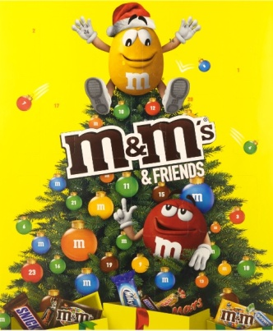
Yellow and Red will guide you through Advent time this year
Charming M&M’s “heroes” Yellow and Red will make waiting for Christmas sweeter for you this year in their own unique and unmissable way. If you are a fan of the exquisite chocolate sweets, you will definitely enjoy the Advent time in a grand way with the help of 361 grams big sweet joy. To 24 windows of their advent calendar M&M´s & Friends invited all popular brands - M&M'S, Snickers, Twix, Bounty, Mars a Milky Way. That means that every day there is going to be one sweet surprise waiting for you. The calendar is a great gift for all your loved ones. But you should also have a treat yourself from time to time.
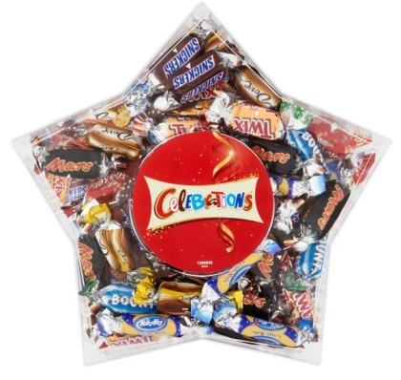
Star filled with delicious joy
Not just decorated tree, Christmas star is also without the doubt a symbol of Christmas time. Why not make your decorations even more special this year with Celebrations Christmas star? Colorful mixture of miniatures of popular chocolate bars Snickers, Twix, Bounty, Mars and Milky Way in a beautiful package will bring magic to any household.

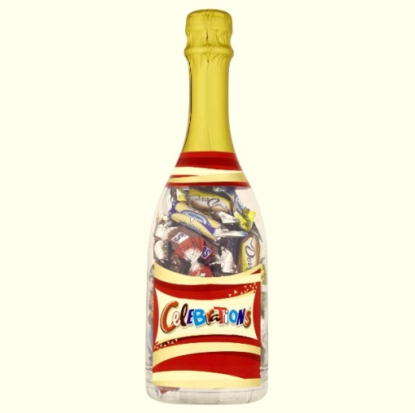
Not all bottles are the same
No matter if you’re looking for an inspiration on what to put inside package from Saint Micholas, on how to be original on New Year’s Eve or simple just for something new – special Christmas edition in beautiful package will bring joy not just to your family, but also for instance to your colleagues. Be creative this year and offer to them Celebrations bottle of chocolate champagne. Because there is never too much of bubbles.
Selection of miniatures of Snickers, Twix, Bounty, Mars and Milky Way chocolate bars in a stylish package will sparkle at any party but also at home among your loved ones. Share sweet joy and enjoy festive moments together.

