Campaign “Help fill the bowls in shelters” celebrates 10 years. The abandoned animals have already been given over two million bowls
Prague, September 18th, 2018 – Tenth annual campaign “Help fill the bowls in shelters” celebrates the cooperation of Mars Czech and the Animal Protection Foundation, and continues the tradition of helping shelters and their four-legged pet friends. Over the past 9 years, incredible two million bowls of Pedigree and Whiskas pet food have been distributed among shelters.
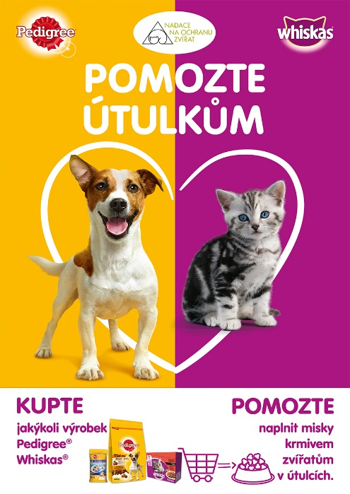
The campaign “Help fill the bowls in shelters” celebrates success every year, which the number of bowls proves. Over the past years, full bowls were enjoyed by 7,497 dogs and 6,573 cats in total of 233 shelters. For shelters, any material support is very important. Saved finances can, for example, be used to reconstruct pens or pay expensive veterinary care.
As usual consumers will help animals in shelters by buying Pedigree® and Whiskas® products. The campaign and its mechanics has been a success year on year and Mars Czech is determined in continuing its partnership in making the world a better place for pets everywhere. The consumer just has to buy any Pedigree® or Whiskas® product in the time from September 10th till November 4th and Mars Czech will donate dry food to cats and dogs in chosen shelters based on the volume sold.
The aim of the campaign is to help improve the situation of cats and dogs in shelters in the Czech and Slovak Republics. Beside material help the campaign tries to further promote awareness and prevention. Together, Mars Czech and Animal Protection Foundation seek to reduce the number of animals placed in shelter by informing the society. The campaign “Help fill bowls in shelters” is the kind of help that works perfectly. Which the campaign partner and its director Mgr. Eva Marlene Hodek confirms: “For beautiful 10 years of cooperation with Mars Czech we have been able to help effectively. It makes me very happy, because the help really gets where it is needed.”

For more information visit www.naplntemisky.cz

